**Real Time Web Based Bus Tracking System**

### 

**Project Code:**

BSCS-AWM-153435 -2025

**Project Advisor:**

Dr. Hussam Ali (Internal)

**Project Manager:**

Dr. Muhammad Ilyas

**Project Team:**

Asma Khanum (TL) – BSCS51F22S015

Mahnoor (TM) - BSCS51F22S034

Wajeeha Safdar (TM) - BSCS51F22S035

**Submission Date:**

6th October, 2025

**Contents**

1. Abstract 3

2. Background and Justification 3

3. Project Methodology 3

4. Project Scope 4

5. High level Project Plan 5

6. References 5

1. Abstract

Passengers in Sargodha frequently experience inconvenience due to the lack of real-time information about bus locations and arrival times at bus stops. The proposed solution is a web application that allows users to track bus locations in real time using global positioning system (GPS) and a centralized database. This system aims to save passengers’ time by providing accurate information about bus locations, routes, and estimated arrival times. The proposed system aims to improve local transport efficiency and passenger satisfaction.

1. Background and Justification

Public transportation systems across the world face issues such as traffic congestion, irregular schedules, and commuter uncertainty. Several international studies have successfully addressed these challenges using GPS-based real-time tracking. Patel et al. (2017) emphasized that passengers can view live bus locations and estimated arrival times through a web interface, while Gharge et al. (2016) demonstrated that GPS and global system for mobile communication (GSM) technologies significantly improve transport efficiency and reduce passenger waiting times.

However, such solutions have primarily been developed and implemented by international researchers and students, with limited adoption in Pakistan. Most public and institutional transport systems here still operate manually, lacking real-time digital coordination. As a result, passengers often face missed buses, poor scheduling, and uncertainty in daily commutes.

To bridge this technological gap, the proposed project aims to design and implement a GPS-based Real-Time Bus Tracking System specifically for Sargodha, Pakistan. By integrating GPS modules with Google Maps and web technologies, this system will provide accurate location tracking for institutional and public transport users, enhancing transparency, punctuality, and overall commuter experience in the local context.

1. Project Methodology

This project follows the Iterative Software Development Life Cycle (SDLC) model to ensure flexibility and improvement at each stage from design to deployment. The system architecture builds upon prior international studies such as Patel et al. (2017) and Gharge et al. (2016), integrating Google Maps application programming interface (API) and Wi-Fi-based live location sharing, making it more applicable to local transport systems in Sargodha, Pakistan. The tools and technologies used in this project include React for frontend development, Firebase for backend and database management, Express.js for server-side logic, and Google Maps API for real-time visualization of bus locations.

The system architecture is inspired by prior international studies such as Patel et al. (2017) and Gharge et al. (2016), who used GPS and GSM-based models to track bus movement and share data with users. Our approach builds upon these concepts by integrating Google Maps API and Wi-Fi based live location sharing, making it more applicable to local transport systems in Sargodha, Pakistan.

In this system, each bus will have a GPS-enabled microcontroller that continuously transmits its coordinates to a central web server. The server updates the web interface or progressive web app (PWA), allowing users to view live bus locations and estimated arrival times.

1. Project Scope

The proposed system focuses on the development of a web-based real-time bus tracking platform designed specifically for the local transport network of Sargodha, Pakistan. The project aims to address the current lack of location-aware digital infrastructure in regional public transportation systems.

The boundaries of the proposed system are defined below to ensure clear deliverables.

**In-Scope**

* Designing and developing a responsive web application that displays real-time bus locations on an interactive Google Maps interface.
* Utilizing GPS modules integrated within buses or drivers’ mobile devices to capture live coordinate data.
* Implementing a centralized backend database for continuous data synchronization and route management.
* Providing users with essential transport details such as bus number, route, estimated arrival time (ETA), and current position.
* Incorporating notification features to alert passengers of bus arrivals or route delays.
* Ensuring the system’s functionality and usability across desktop and mobile browsers through PWA design principles.

**Out-of-Scope**

* Integration with digital ticketing or payment systems.
* Development of a dedicated native mobile application (Android/iOS).
* Implementation of AI-based predictive analytics or route optimization algorithms.
* Coverage of private, intercity, or non-governmental transport vehicles.

1. High level Project Plan

The Real-Time Web-Based Bus Tracking System will be developed through structured phases. Each phase focuses on a specific set of deliverables to ensure system reliability, user experience, and technical performance. The following table outlines the major phases, expected outcomes, and duration for each activity.­­­­­­

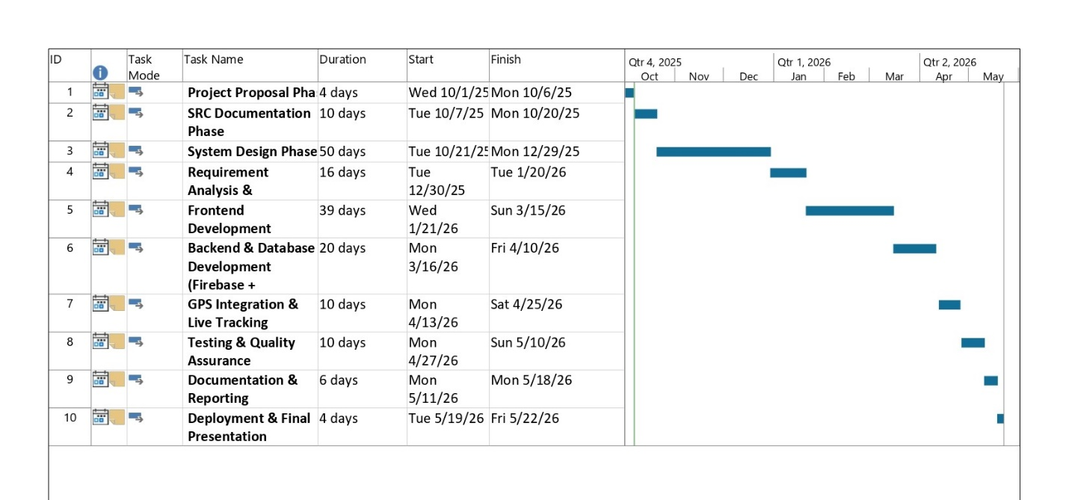

|  |  |
| --- | --- |
| Phase / Activity | Key Deliverables / Outcomes |
| Requirement Analysis & Feasibility Study | Stakeholder requirements document, feasibility report, and use-case definitions for Sargodha’s public transportation routes. |
| System Design | System architecture diagrams and user interface (UI) wireframes demonstrating integration between React frontend, Firebase backend, and Google Maps API. |
| Frontend Development (React) | Responsive React-based web interface with modular components for user dashboard, bus tracking map, and route visualization. |
| Backend & Database Development (Firebase + Express.js) | Functional backend architecture using Express.js; Firebase setup for real-time updates, authentication, and cloud database integration. |
| GPS Integration & Live Tracking | GPS data module integrated with Google Maps API; live coordinate updates tested with simulated bus movement. |
| Testing & Quality Assurance | Completed test cases, bug reports, and validation logs ensuring system stability, GPS accuracy, and responsive UI performance. |
| Documentation & Reporting | Technical documentation, system manual, and finalized project report aligned with institutional submission standards. |
| Deployment & Final Presentation | Deployed web application on Firebase Hosting with a demonstration of live tracking and full project presentation. |

1. References

[1] Patel, D., Seth, R., Mishra, V., & Pathari, R. (2017). Real-time bus tracking system. International Research Journal of Engineering and Technology (IRJET), 4(3), 743–746.

[2] Gharge, S., Chhaya, M., Chheda, G., & Deshpande, J. (2016). Real-time bus monitoring system using GPS. International Journal of Science and Research (IJSR), 5(5), 918–921. (Gharge, 2016)